Lecture 16: Income Taxation

Professor Raj Chetty, Harvard University

**1. Federal Tax Revenues:**

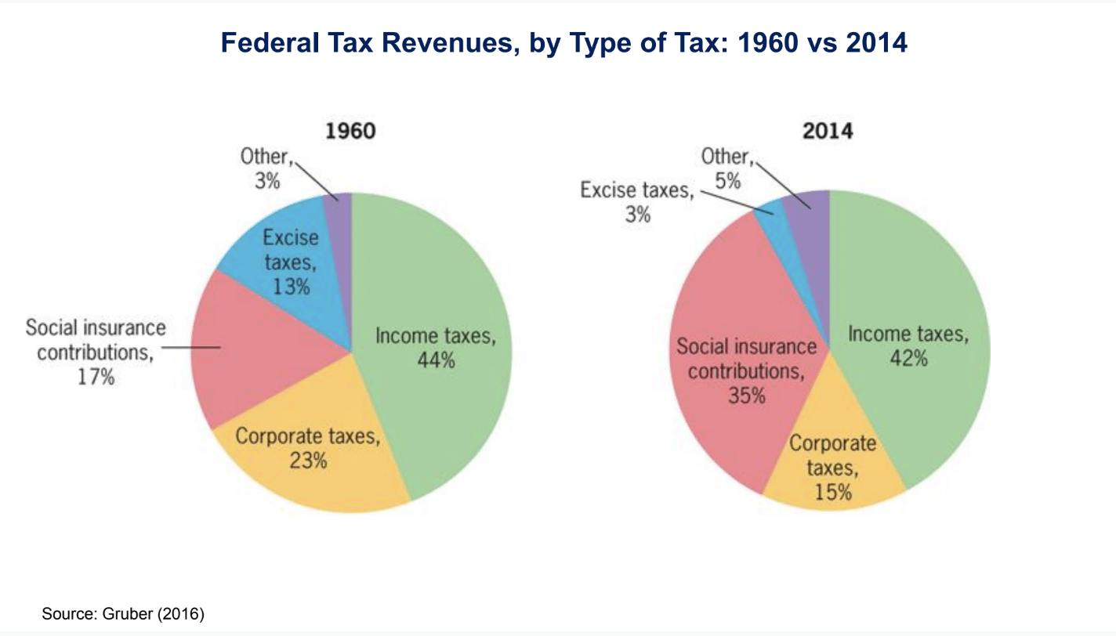

* This is a pie chart depicting the sources of revenue for the federal government. In 1960, 44% of government revenue came from income taxes, 23% from corporate taxes, 17% from social insurance contributions. Social insurance contributions are things like Social Security tax, Medicare tax, unemployment insurance tax.
* In 2014, the pie chart is similar, but the main change is that the corporate tax base has shrunk a fair bit.
  + There are reports about companies like Amazon paying little or no federal income corporate tax, and there is a big discussion about the potential need for corporate tax reform in the United States because very profitable companies end up paying very little tax through various avoidance mechanisms, and that is reflected in the fact that we have a smaller share of corporate tax revenue now.
  + A much bigger share is coming from the social insurance contributions as programs like Social Security, Medicare, disability insurance have expanded substantially, and those taxes have become much more important for the federal government.
  + The question economists are interested in is whether or not this makes sense. Should we have this combination of taxes? Should we be raising 40% of our revenue from income taxes? Should we be changing the corporate tax system in some way? We may also want to compare the US to other countries.

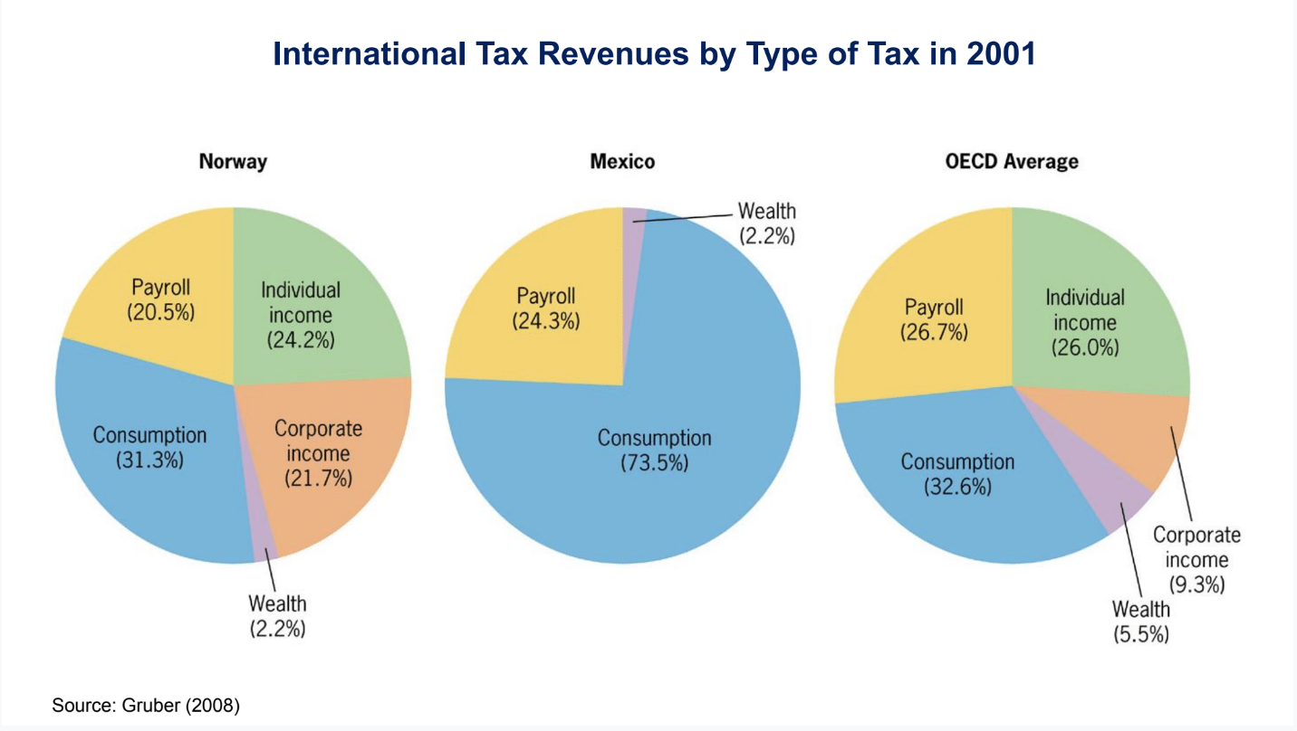

* Norway, for example, raises only 25% of revenue from income tax, unlike the US, where we saw it was more than 40%. They raise a lot of money through consumption taxes, and in particular, value-added taxes, which are analogous to a sales tax but implemented differently.
* If we look at a couple of other examples, such as Mexico, they have a much larger reliance on consumption taxes and essentially no reliance on income tax. In Mexico, everything in the government is financed more or less through taxes on what people are buying and selling and not on the income that they are earning, partly for enforcement reasons.
  + It is very difficult to enforce an income tax unless a country has excellent records. Looking at the OECD countries on average, the US is a bit of an outlier. Most OECD countries have a lot of consumption taxation. Many countries tax people on consumption rather than what they earn, which is the predominant form of taxation in the US.
* We will focus on two key aspects of tax policy. The design of income tax systems and the taxation of savings and focusing on retirement savings policy. We will need to use an empirical approach called synthetic control, which is sort of a generalization of difference-in-differences methods that are very useful in lots of contexts.

**2. Marginal vs. Average Tax Rates:**

* Most developed countries have progressive income tax systems. A progressive tax is one where tax rates rise with income, therefore this tax means that the rich pay a larger proportion of their income in taxes than the poor. Typically, a progressive tax system is implemented with a set of separate tax brackets that are based on one’s income.

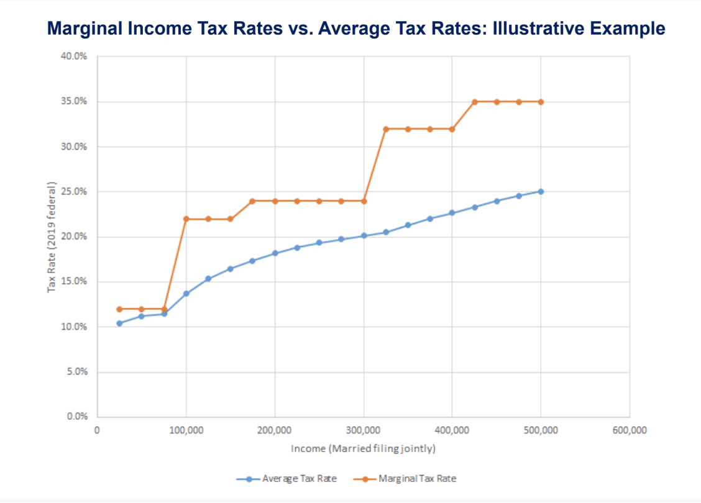

**3. Top Marginal Tax Rates:**

* What is the tax rate on an extra dollar that an individual earns in each of those brackets?
  + If someone’s income is below $80,000 a year, they pay a marginal tax rate of about 12%. For every extra dollar they earn, 12 cents of that goes to the federal government. If they cross into the next bracket, and have a $100,000 income, on that next dollar that they earn, they pay 22 cents to the government rather than 12 cents.
  + As someone goes to higher and higher income levels, every extra dollar they earn, they pay 35 cents to the government, so it is critical to draw a distinction between marginal and average tax rates. The marginal tax rate shown by the orange series here means on the margin, that is, for an incremental dollar, how much does someone pay to the government in taxes? The marginal tax rate goes up with income in the US tax system and tops out at 35%.
* There is a particular focus on marginal tax rates on the highest income earners because there is a tremendous concentration of income at the very top of the distribution, where the top 1% of income earners in the US earn close to 20% of total income. Whatever the government does to marginal tax rates at the very top of the distribution will have a big impact on government revenue.
* Second, especially in the context of the current political climate, there is a focus on inequality. People are focused in particular on the upper tail, the top 1%. Top income tax rates have fluctuated significantly over time in the US as a result of the strong debate regarding the subject.

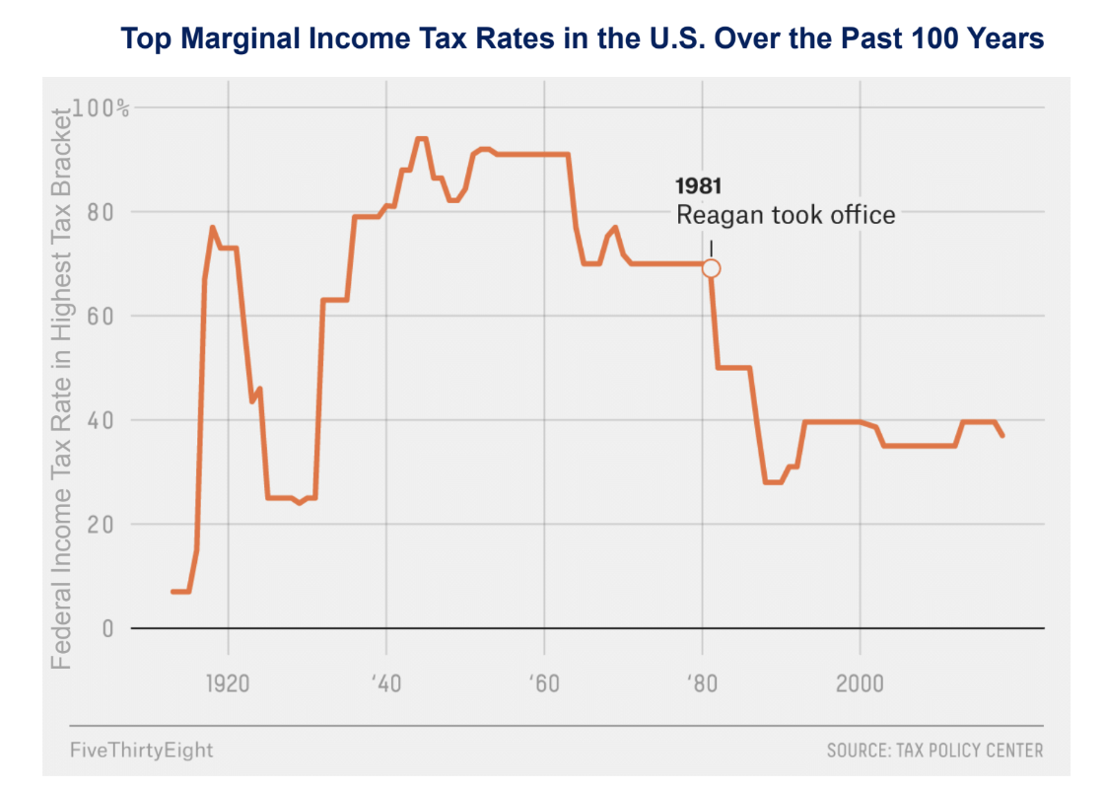

* In the prewar period, we had marginal tax rates that initially were very low as the income tax was basically coming to be in the United States. Then, marginal tax rates went up to around 70%, came down, and then we had exceptionally high marginal tax rates around 90%.
  + An extra $1,000 at the very high end of the income distribution in 1950 resulted in $900 of those dollars going to the government, and the earner keeping $100. After that point tax rates have been cut extremely sharply and in particular in the 1980s when Ronald Reagan took office and there was a big push towards reducing tax rates. Tax rates came down from around 70% down to the current levels of about 35% to 40%.

**5. Economic Approach to Optimal Taxation:**

* What is the right rate and how can we tackle the question from an economic perspective?
  + Often, people think of the choice of tax rates as a completely political issue, and those on the left and right debate these issues ad nauseam. However, there is a more scientific approach that can at least give us a clue as to what might be optimal, outside of value judgments.
* The economic approach to thinking about optimal taxation is to consider the tradeoff between equity and efficiency.
  + An additional dollar of income is worth more in terms of utility or well-being to a person who is low income, say a family earning $10,000 a year, than to a person who is high income, say earning $250,000 a year. The logic of that is a simple diminishing marginal utility concept. If someone has a lot of money, that extra dollar is not worth much. If we go to the extreme of having no money at all, to the point of starvation, an additional dollar is incredibly valuable.
  + That basic logic suggests that there might be some desirability to having more equity in society if a dollar in the hands of a low-income person is worth more than the dollar in the hands of a high-income person.
  + Total social welfare would be maximized by having a more equal distribution of income. That equity force pushes toward higher tax rates on high-income earners to reduce inequality in the economy.
* The other aspect of the tradeoff is to think about efficiency.
  + The higher the tax rates we have on the rich, the less of an incentive high-income people have to work.
  + Thinking back to the case where there are 90% or 95% tax rates on very high-income earners, we can imagine that some earners may say it is not worth it to think about starting a business or think about doing work to generate more money. As a result of that type of behavioral response, there could potentially be less economic innovation. There may be less entrepreneurship, maybe less economic growth, and that would be detrimental for the economy.
  + The efficiency force is going to push towards lower tax rates on high-income earners, hence the tradeoff. If we have higher tax rates, we have more equity, but less efficiency. The optimal tax system balances the gain from equity with the efficiency cost.
* We want to quantify the two aspects of this tradeoff and then find the tax system that gets to the best point given that tradeoff.
* The gains from equity rely on value judgments. To put it in numerical terms, we need an answer to the question, ‘How much more is money worth to a low-income household than a high-income household?’
  + If I were to give a high-income household an extra $1,000, how much would that be worth to them? Economists typically believe this is a judgment people have to make for themselves. Imagine we get some answer, as we are going to take that as an input in this analysis of optimal taxation.

**6. Labor Supply:**

* Where economists have done a lot more work is to try to understand the efficiency impacts of changes in tax rates.
  + In particular, the efficiency impacts of the tax system are going to depend upon how much rates of work are affected by changes in tax rates. If taxes increase to 70%, how much less are people going to work? That is a question we should be able to study in the data and quantify directly.
  + Given that, there is a large literature in economics on estimating what is called the elasticity of labor supply using modern tax data.

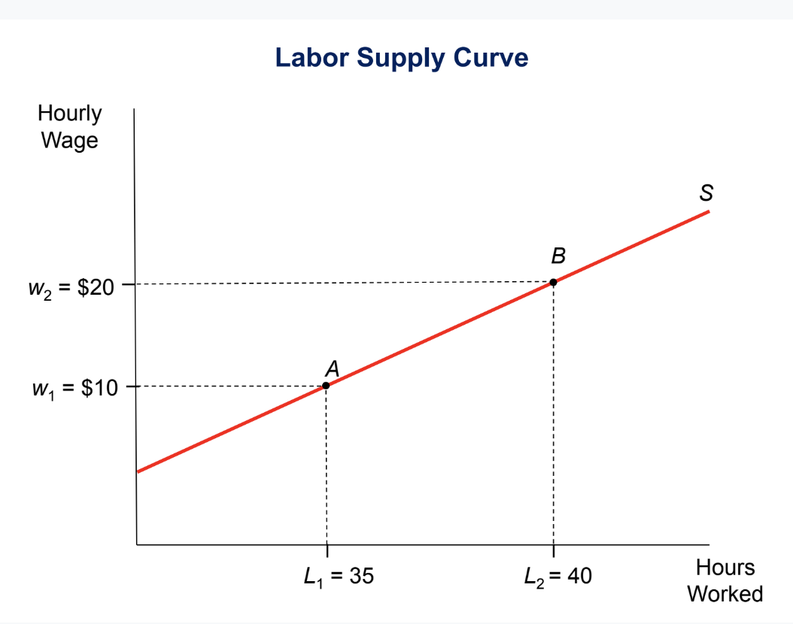

* This is a sample labor supply curve.
  + On the vertical axis is hourly wage. On the horizontal axis is the amount of labor being supplied in the economy, which is the number of hours that people choose to work. The simple idea is that if workers get paid more, they may want to work more. In this example that is constructed here, if we have a wage rate of $10, the average person chooses to work 35 hours a week. If the wage rate is $20, they choose to work 40 hours a week.
* We are interested in the slope of that curve—how responsive are people to changes in the wage and changes in the tax rate, which effectively changes wages?
* The concept that economists like to use to measure that slope is called elasticity which is essentially a measure of responsiveness.
  + Formally, the way that is defined is. When I have a wage rate change of a certain amount, what is the change in labor supplied? If the elasticity is .5, it means that when I increase the wage rate by 10%, people work 5% more. If the elasticity is one, it means that when I increase the wage rate by 10%, people work 10% more.
  + The elasticity is a simple way to quantify how responsive people are to changes in the wage. We can visually distinguish cases where we have less elastic labor supply.

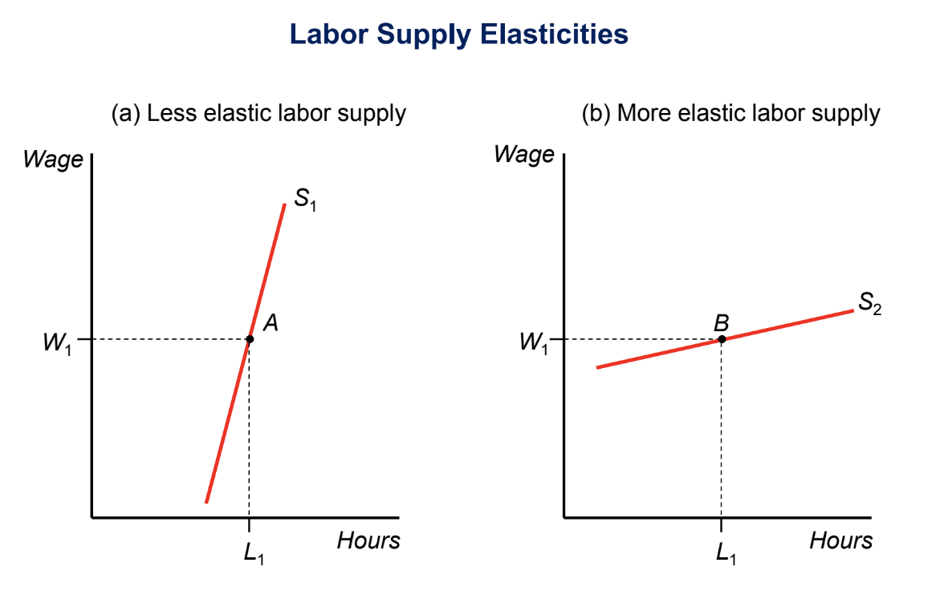

* In the diagram on the left, there is very little impact on the amount that people work, which is a case with a low labor supply elasticity. The case on the right illustrates a situation with a very elastic labor supply. As we change wages or tax rates by a little bit, the amount people choose to work changes dramatically, and that is going to be the situation in which there is a big efficiency cost to raising tax rates because the amount people are working is going to change a lot as tax rates increase.

**7. Revenue- Maximizing Tax Rate:**

* As mentioned above, the way economists think about optimal taxation is the tradeoff between equity and efficiency. The equity part is hard to quantify.
  + However, in an extreme scenario, the limiting case is when we place zero social value on additional income for people in the top 1%. If someone is earning $500,000 a year and their income goes up to $510,000, suppose we put zero social weight on that. That is the minimum weight. That is a case where the optimal tax rate on the rich would be 100% because we do not place any value on their income. However, that is not the right way to think about it. The optimal tax rate in the top bracket is never going to be 100%, and the reason for that is illustrated by the Laffer curve.

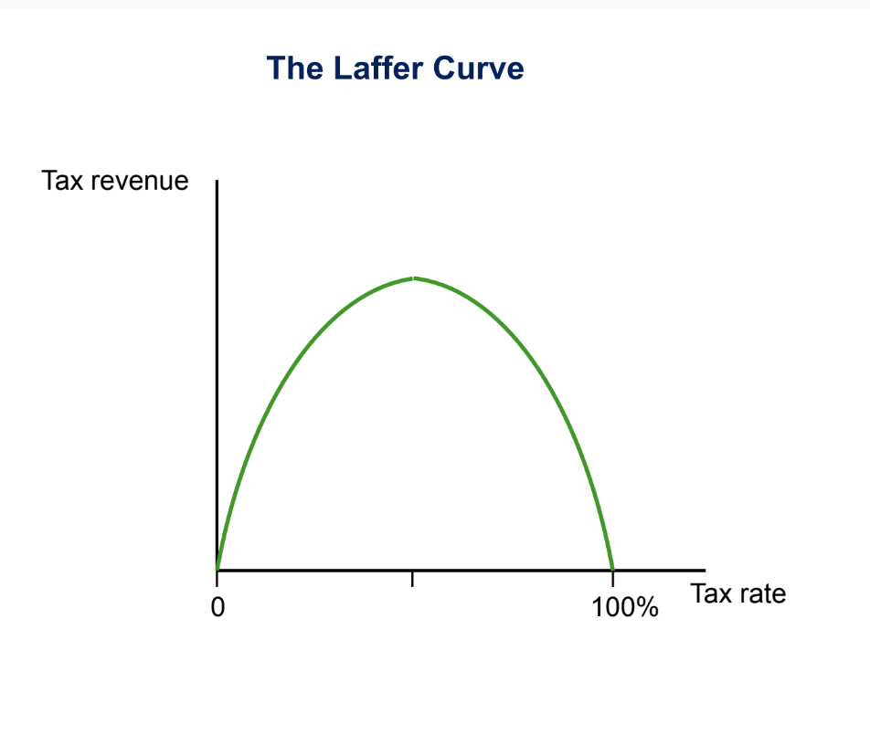

* This is a hypothetical illustration of tax revenue as a function of the tax rate.
* The exact shape of this curve is going to vary depending upon the specific parameters of the economy and how people choose to behave and so forth, but the curve captures a very important idea.
  + It has an inverted U-shape, and in particular, it is at zero both at a tax rate of zero and at a tax rate of 100%. At a tax rate of zero, there is zero tax revenue.
  + Less obviously, if the tax rate is 100% there is zero tax revenue. If the government is going to tax 100% of incomes, nobody is going to work.
  + The simple way to think about it in a labor supply model is that the government is driving wage rates to zero, and at a wage rate of zero, the level of labor supply is going to be zero. With this parabolic shape, there must be a revenue-maximizing tax rate denoted by tmax, which is the maximum revenue.

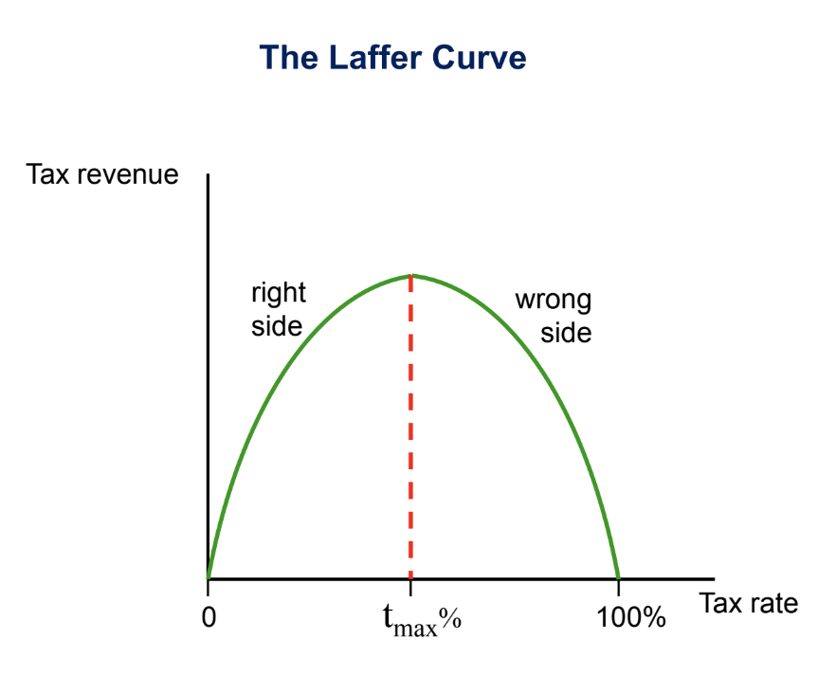

* This curve was drawn on a napkin by an economist called Arthur Laffer when he was having lunch with Ronald Reagan, and this led to the supply side revolution in economics.
  + His point was, if the government is on the wrong side of the Laffer curve where they have tax rates that are too high, perhaps they could cut tax rates and actually generate more revenue for the government while giving more income to top income earners as well.
  + This illustrates that governments should not be on the wrong side of the Laffer curve because they are hurting themselves from the perspective of collecting tax revenue, and they are not benefiting high-income earners either.
* Tax revenue—call it R—is the product of two things.
  + Imagine a simple system where we have a constant tax rate on all incomes. If the tax rate is t, then the amount of revenue collected is t times L(t), which is the total amount of work that people are doing in the economy. L(t) is the total of hours of work multiplied by wage rates—the income tax base. At a tax rate of zero, we are multiplying zero times L(t) which is zero. At a tax rate of 100%, L(t) is going to be zero. We are trying to find where that function is maximized. It is the point where the derivative is equal to zero. After solving that equation, we see that the revenue-maximizing tax rate is .
* Suppose the elasticity is zero. That is the case where people do not change the amount they work at all based on tax rates. In that case, we maximize revenue with a tax rate of 100%.
  + If people work the same amount no matter what the tax rate is, then we might as well set the tax rate to 100% because people are going to work the same amount. If the elasticity were .25, so when I increase your wage by 10%, you work 2.5% more, then the revenue-maximizing tax rate is 80%. If the elasticity were one, changing wages by 10% changes the amount that people work by 10%, then the revenue-maximizing rate would be 50%.

**8. Laffer and Supply-Side Economics:**

* Returning to the idea of the Laffer curve and supply-side economics, Arthur Laffer argued that the US was on the wrong side of the Laffer curve in the 1980s.
  + In particular he argued that cutting taxes would both increase tax revenue and simultaneously stimulate economic growth. That argument and a broader movement around that time motivated very large top-income tax cuts enacted by Reagan as shown before.
  + We can now ask with Big Data if the Laffer argument is actually empirically valid. That is a scientific claim that says that cutting tax rates will increase the amount that people work enough that the government will actually collect more revenue. There are a series of modern studies that estimate this critical elasticity of labor supply that we have identified as the key thing here using difference-in-differences looking at changes in tax policies and looking at how they affect how much people work.
  + Typically, economists analyze the impacts of a change in tax rates for one group. For example, there might be a tax cut that applies just to high-income people, and use other groups in the economy, like middle-class people or lower-income people, as the control group for whom nothing changed at the same time.
* One example of that is from a study by Kleven and Schultz using Danish data. Some of the best studies in this literature use Scandinavian data because historically they have had better data on incomes from administrative data sources than the US.

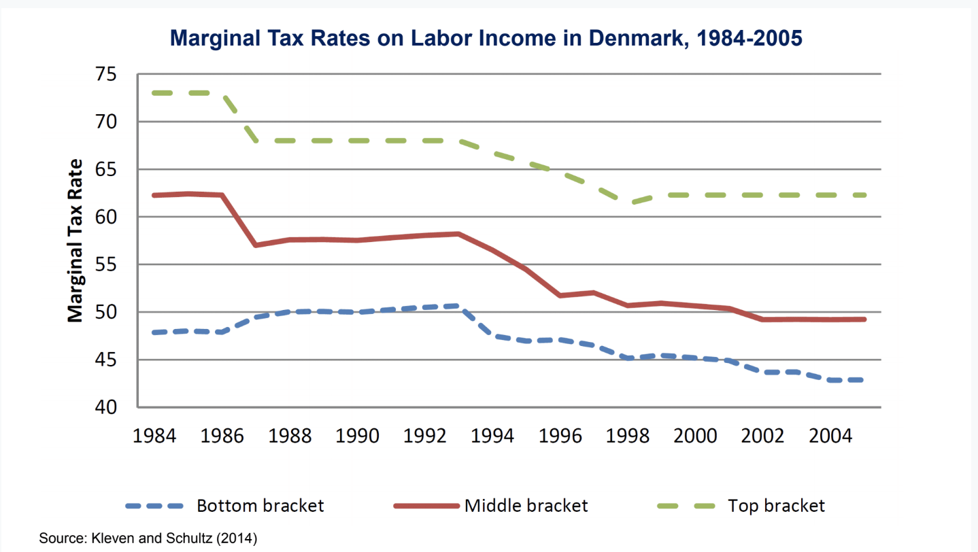

* The above graph plots marginal tax rates over time.
  + The top bracket faced a marginal tax rate of about 72% in 1984. The middle bracket faced a marginal tax rate of about 62%, and the bottom bracket faced a marginal tax rate of 48%.
  + In 1987, there is a sharp reduction in tax rates. It was around the same time as the supply side phenomenon in economics, where people thought that cutting tax rates could stimulate the supply of labor and increase economic activity. They cut tax rates at the top and for the middle class, but for the bottom bracket, they did not change tax rates at all.
  + This lends itself nicely to a difference-in-differences design where they use the blue as the control group and use the red and the green as the treatment groups that experienced a change. Then, they look at the amount that people were working and earning after the reform versus before the reform in the treatment group versus the control.

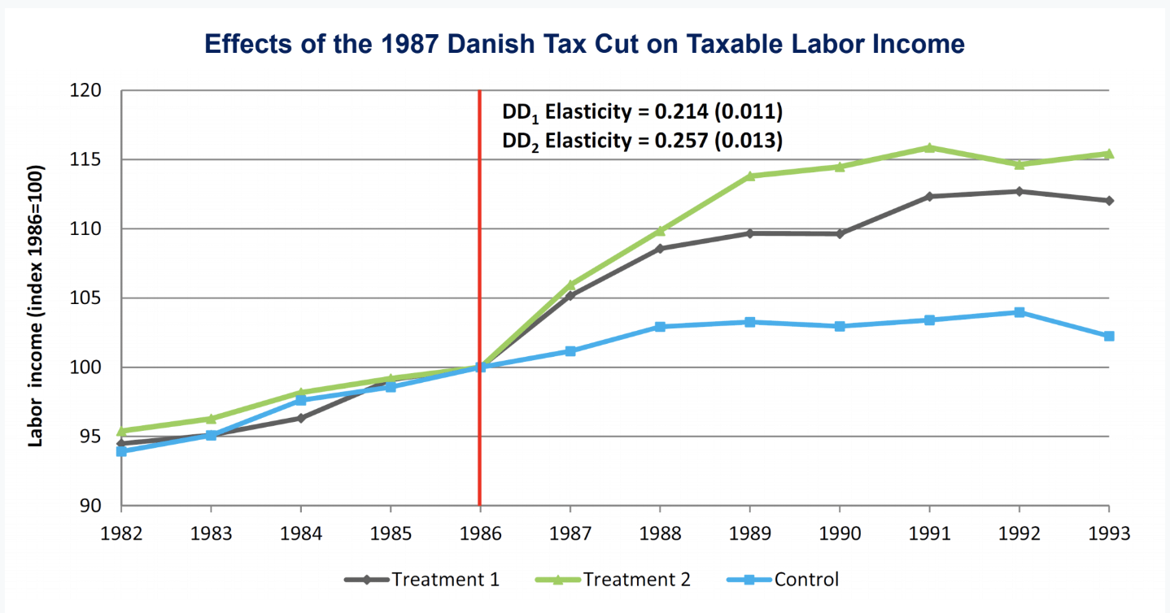

* The blue is the control, which represents people who were in the bottom bracket. The gray represents people who were in the middle bracket, and the green is earners in the top bracket. Before the policy change occurred in 1987, the three lines were moving together very closely, which supports the parallel trends identification assumption.
  + When they cut taxes, the amount that people in the middle and high-income groups were earning went up fairly significantly. Relative to the normalized value of 100 in 1986, in 1988 or 1989, it is about 10%-15% higher in terms of the amount that people are working and earning relative to the value in 1986. This clearly rejects the view that people's behavior is insensitive to taxes.
* The reported elasticities on this chart are around .2 or .25. A 10% increase in the wage seems to translate to about a 2% change increase in the amount that people work. That implies that the revenue maximizing tax rate may be around 75% or 80%.
* Another approach that is similar in spirit is to use state-level variation as a natural experiment.
  + A very interesting case that received a lot of attention in the past few years is a tax cut that was enacted in Kansas in 2012. Two key elements of the income tax change were a reduction in the top state income tax rates from 6.45% to 4.9% and a reduction in business income taxes to zero. Was Governor Sam Brownback correct in his supply-side policies?

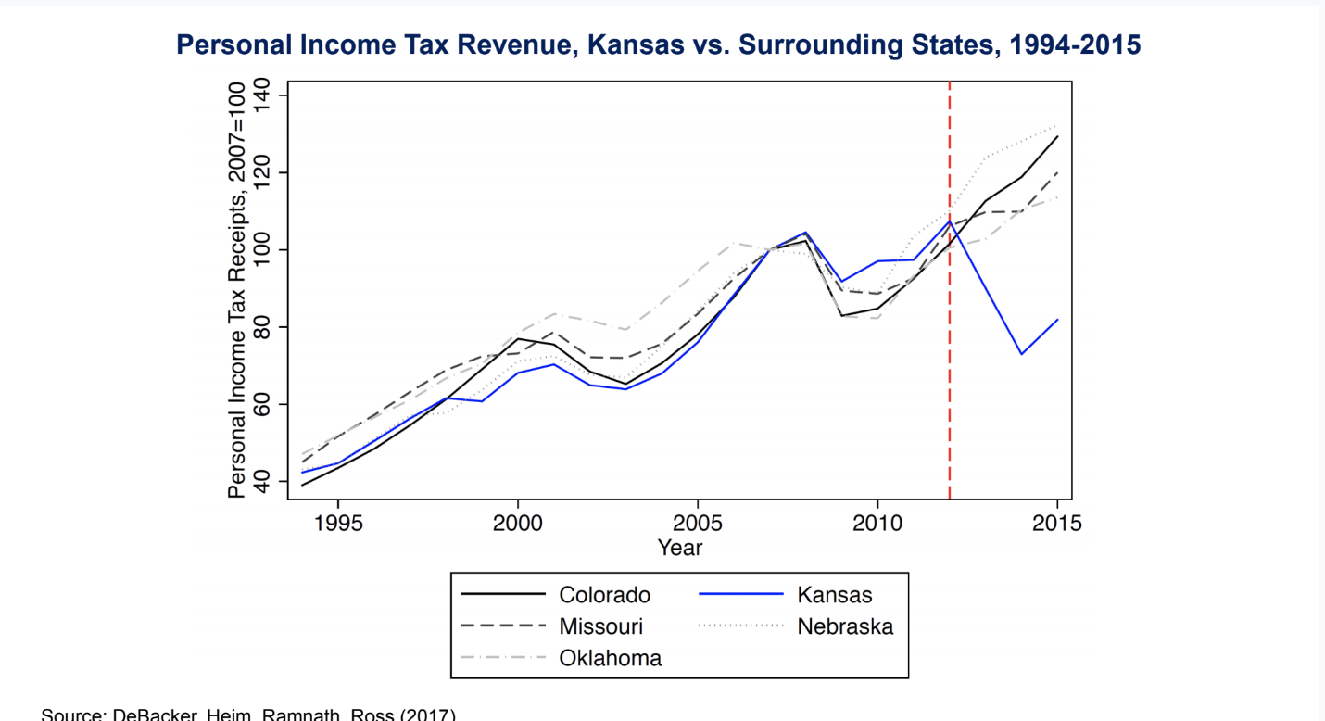

* This plots personal income tax revenue over time before and after this policy change, again doing a difference-in-differences analysis comparing trends in tax revenue in Kansas to other surrounding states.
  + Kansas is highlighted in blue, and it is extremely clear that when they cut taxes sharply it is not the case that tax revenue went up. In fact, it fell very sharply relative to the other states where tax revenue went up after 2012.
  + They are not on the wrong side of the Laffer curve. The extra amount that people start to work does not come close to offsetting the mechanical effect of having a lower tax rate on incomes.
* The literature generally suggests that the elasticity of labor income with respect to wage rates is pretty modest, around .2 or .3, which means if we place relatively low social value on the incomes of very top earners, optimal tax rates might be quite high.
* It is precisely that logic that has led to a recent interest in thinking about significant increases in tax rates on top incomes. Peter Diamond, who is a Nobel Laureate, worked on these issues, and Emmanuel Saez, whose work is reflected in a lot of what we are talking about here had an editorial last year where they say that high tax rates will not slow growth basically based on this logic: "According to our analysis of current tax rates and their elasticity, the revenue-maximizing top federal income tax rate would be in or near the range of 50% to 70%." This has also gotten picked up more recently by Alexandria Ocasio-Cortez, who suggests a 70% tax for the wealthy, as one way to fund policies to address climate change.